Capabilities SpecterX Google Drive Connector

Version 1.01

01.30.24

SpecterX Google Drive Connector
SpecterX SaaS Connectors are API integration modules that seamlessly embed SpecterX into third-party applications, ensuring security policies are enforced when data is exported or shared from managed environments. The SpecterX Google Drive Connector enables users to securely share files within Google Drive through a Chromium browser-supported integration.

User Experience
Secure sharing through SpecterX within Google Drive is enabled through integration with the “Open with” feature of Google. This allows for supported files to be sent to a recipient by email with SpecterX protections applied as the data leaves the controlled application.

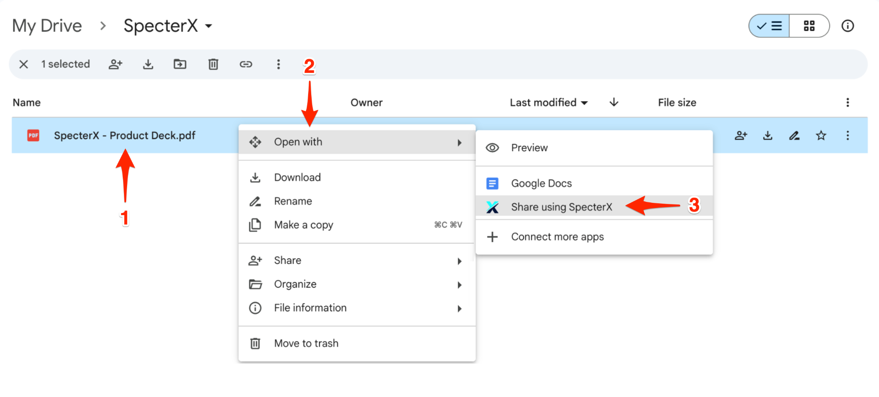

After selecting the SpecterX application, a new browser window will open, allowing the user to apply a SpecterX policy and set recipient permissions via email. The user can choose to automatically notify the recipient with a secure email sent through SpecterX, include an encrypted message, or copy a secure access link to share through another channel. If the assigned policy requires phone verification, the page will prompt the user to enter the recipient’s phone number or display a preview of the preregistered number in the SpecterX system.

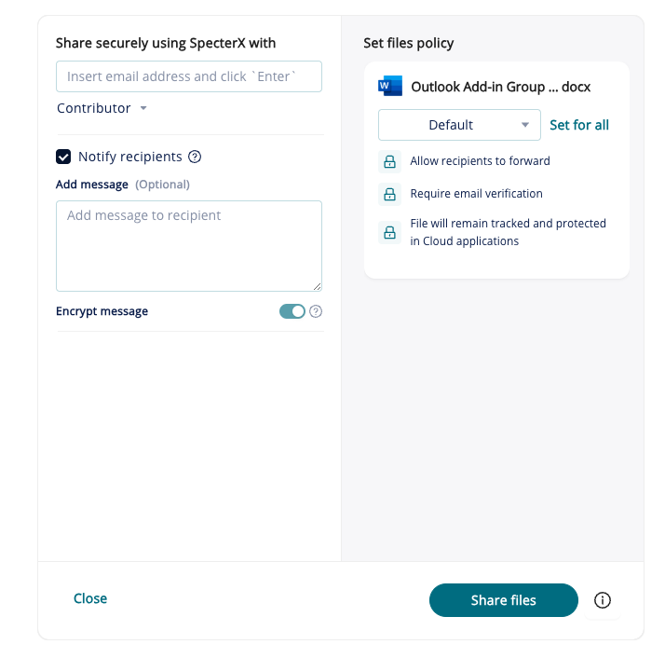

Policy Implementation
SpecterX policies are created by admins within the SpecterX WebUI and are made available for assigned users with the Google Connector installed. Admins can establish policy defaults or allow selection from approved policies per user group or tenant wide. If required, further integration allows for admins to override a user’s policy selection to enforce the organization's security needs.

Connector Installation
The SpecterX Google Drive Connector can be deployed by admins remotely to users from the Google Admin pane. The Connector can also be implemented by users directly from the SpecterX WebUI through a link to the SpecterX app within Google Marketplace.

Supported File
The SpecterX Connector supports all default file types and allows additional file formats to be enabled during onboarding. Any file types that are not included in the default set or custom additions will not appear as options within the SpecterX Application’s 'Open With' menu.

Default file types enabled by the SpecterX Google Drive Connector:

Documents: .doc, .docx, .pdf
Spreadsheets: .xls, .xlsx, .csv
Presentations: .ppt, .pptx
Compressed Files: .zip
Images: .png, .PNG, .jpeg
Videos: .mp4
Scripts: .js

For information on implementing SpecterX Connectors, please connect with the SpecterX team.

